## ONLINE CRIME REPORTING & MANAGEMENT SYSTEM

A PROJECT REPORT

***in partial fulfillment for the award of***

***the degree of***

BACHELOR OF ENGINEERING

## COMPUTER SCIENCE & ENGINEERING



|  |  |  |
| --- | --- | --- |
| **Submitted to:** | **Submitted By:** |  |
| Nivedita Sharma(E13313) | Aditya Raj | (20BCS9168) |
| **Supervisor** | Abhinandan Gupta  Sujata Singh  Ajay Rawat  Subhansh Bhardwaj | (20BCS9264)  (20BCS7295)  (20BCS9294)  (20BCS8000) |

**BONAFIDE CERTIFICATE**

This is certified that the work embodied in this Project Report entitled “**ONLINE CRIME REPORTING & MANAGEMENT SYSTEM”** being submitted by “**Aditya Raj**” UID “**20BCS9168**” “**Abhinandan Gupta** ” UID “**20BCS9264**”, “**Sujata Singh**” UID “**20BCS7295**” “**Ajay Rawat**” UID “**20BCS9294**”, “**Subhansh Bhardwaj**” UID “**20BCS8000**” who carried out the project work under my/our supervision.

#### SIGNATURE SIGNATURE

Deepika Sood (E10446) Nivedita Sharma (E13313)

**(HEAD OF THE DEPARTMENT) (SUPERVISOR)**

Submitted for the project viva-voce examination held on

INTERNAL EXAMINER EXTERNAL EXAMINER

# ACKNOWLEDGEMENT

A web-based system for managing online criminal records. To report the FIR in online system so to avoid bulk of files and to avoid wastage of papers. The application will provide a foundation for executing the crime management system, an essential procedure with several computations and activities. It will result in consistent and quick response against reported crimes. The data may be collected quickly and correctly. This web service provides an interface with which the user can access, log new Complain and Track his complaint status. This system will help Police Department to maintain crime data and plan their investigation much efficiently. With this web service, it will be much easier and beneficial for both the user and police department.

# TABLE OF CONTENTS

1. Introduction 11-12
   1. Client Identification 11
   2. Identification of Problem 11
   3. Identification of Task 11
   4. Timeline 12
2. Literature Review 13
   1. Crime 13-15
   2. Types of Crime 15
      1. Normal Crime 18
      2. Political- economic Crime 19
      3. Riotous Crime 20
   3. Factors Leading to Crime 21
      1. Ordinary Factors 21
         1. Geographical 21
         2. Sociological 22
         3. Physiological And Atmospheric 22
      2. Specific Factors 23
         1. Family Circumstances 23
         2. A ruined family 23
         3. The size of the family 23
         4. Discontentedness in the family 23
         5. Fallen Family 24
         6. Absence of Orderliness in the family 24
         7. The Movies 24
         8. Financial Conditions 24

* + - 1. Regional Variance 25
      2. Religious Radicalism 26

2.3.2 Electronic Crime Reporting Platforms 26

* + 1. Limitations of Existing E-Crime Reporting Plan 27
    2. Justice System in Nigeria 28

1. DESIGN FLOW/PROCESS 29-33
   1. Project Dataflow 29
   2. Project Modules Description 29
      1. Homepage 30
      2. User Login Page 30
      3. Official Login Page 30
      4. Police Officer Login Page 31
      5. Station Incharge Login Page 32

3.2.6 Head Quarter Login Page 33

4. Result Analysis and Validation

4.1 DATABASE ENTRIES: 34-36

5. Outcome and Work Ethics 37-45

5.1 Result 37

5.1.1 Home Page 37

5.1.2 User Registration page 38

5.1.3 User Home Page 38

5.1.4 Official Login Page 39

5.1.5 Police Officer Login page 39

5.1.6 Police Officer Home Page 40

5.1.7 Station In-charge Login Page 41

5.1.8 Station In-charge Home Page 42

5.1.9 Head Quarter Login Page 42

5.1.10 Head Quarter Home Page 43

5.1.11 New Police Station add Page 43

5.2 Application 44

5.3 Conclusions 44

5.4 Future Scope 45

5.5 References 45

**LIST OF FIGURES**

Fig. 1: Dataflow Diagram 18

Fig 2: Database and all the tables inside the database 28

Fig 3: Complaint table: All the registered complaints will store here 29

Fig 4: Head Table: All the Head Quarter Login Details will store here 29

Fig 5: Police Table: All the police officer’s details will store here 30

Fig 6: Police Station Table: All the Station Details 30

Fig 7: Update_Case Table: All the case progress details will store here. 31

Fig 8: User Table: All the registered user details will show here 31

# List of Tables

Table 1: Crimes committed in States, by number of incidents and fatalities (Adapted from Ukoji et.al (2016)).

Table 2: Crimes fatalities in Nigeria between June 2006 – September 2015(Adapted from Ukoji et.al (2016)).

**ABSTRACT**

We will design a web application that will provide a platform to report all manners of crimes. We will also provide a platform for different security agencies and their representatives to be registered; with a dashboard to view and interpret different report incidences. The general public will also be able to freely report, get feedback and evaluate progress of reported cases without to fear or intimidation. The application will be data driven and user experience will be responsive and consistent. The applications will be accessible over the internet on computers and other mobile devices. No other hardware resources will be required and the evaluation will be mainly experimental.

# CHAPTER 1

# INTRODUCTION

* 1. **Client Identification**

The systems that are now accessible fall well short of the potential of technology for reporting crimes. The platforms are not widely used and are not easy for regular people to utilize. The platforms lack feedback from the society's citizens, making them unidirectional. Due to all these shortcomings, we are interested in developing a perfect application that will fix the shortcomings.

We are eager to create a comprehensive web platform that records all types of crimes, is accessible to the general public, suggestive (search for entities), interpretive, and illuminating. The platform will give different security agencies a place to discuss and gather evidence, rally the public for particular causes, and conduct investigations that will lead to better policing, crime prevention, and investigation.

### **Identification of Problem**

The creation of a comprehensive digital platform that records all types of crimes, is accessible to the general public, suggestive (search for entities), interpretive, and illuminating is something we are looking forward to. The platform will give different security agencies a place to exchange information, compile evidence, and rally the public around causes that will improve policing, crime prevention, and investigation.

### **Identification of Task**

This web service provides an interface with which the user can access, log new Complain and Track his complaint status. This system will help Police Department to maintain crime data and plan their investigation much efficiently. With this web service, it will be much easier and beneficial for both the user and police department.

With the help of this web service, the user will be able to register a complaint without any hassle. Also, due to this pre-register system, police department can now manage the time and investigate the case.

### **1.4 Timeline**

This project requires around 3 months of time

* + - During the first 2 weeks, research on similar work that is Literature Review is done
    - In the following 1 week the requirement analysis is done
    - In the next week all the required tools and software’s are analyze.

**CHAPTER 2**

# Literature Survey

**2.1. Crime**

Well and meaningful societies in the world frown at crime and any social vices that undermine the collective safety and values that have been adopted in that society. Crime persists as long as human society exist, therefore there is a continuous effort and legitimacy to report, investigate and provide convincing evidences to prosecute individuals who perpetrate any criminal activity. The word Crime originated from the Latin word Crimen dubbed charge or offence. Shodghangha (2011) projected Crime as a function of the adoption of standards by the society rather than individualistic standards, that is, the society gradually determine what is perceived as good value and bad acts and proscribe possible consequences. Tappan (2001) defined Crime as an intentional act in violation of criminal law which is without an excuse. Sampson et.al (1993) also defined Crime any act or omission that is forbidden by law that can be punished by imprisonment and/or fine after due hearing in a law court. Elizabeth (2003) expressed a holistic definition of Crime as an act that is not just harmful to some individuals but also to the state or general public.

The determination of what is obnoxious or sane is determined through a long and continuous complex interactions and reactions among members of a society. As society varies so what is considered as crime varies from people to people. Wilson et.al (1985) argued that there cannot be a general theory to define Crime for all societies because of the diversity of human society and culture. More so, Gottfredson et.al (1990) and Sampson et.al (1993) had a different view, stating that differences in cultures and societies do not really matter but the common characteristics in cultures can be identified and a general theory can be formulated to prescribe what the society should adopt as a crime, that is criminologist should not isolate crimes but to look for the commonality in crimes so as to propose a general rule to determining Crime for all societies. The dynamism of culture and unpredictability of human make it unlikely to have a general set of rules for all human societies.

No continent is left out; Ukoji et.al (2016) reported that Africa is considered a flash point for high crime. He noted that giants of Africa like Nigeria and South Africa now have high records 16

of violent crimes in recent time. America also has high crime index while some places in Europe have been able to crime index by few digits.

Another important component of the justice system is the crime investigation and prosecution. The general knowledge of what Crime constitutes is not enough without ultimately punishing the offender to serve as deterrent and freeing the falsely accused persons in such occasions. The general justice system constitute the laws; which indicate what Crime is, the law apparatuses like security agencies, people and processes that are followed to implement justice. The people who are to be served by the justice system may soon begin to lose confidence and underreport or result to jungle justice to redress their anger if existing justice system continues to fail with time. Criminal justice system also constitute the system of practices and institutions of Government directed at ensuring social control, deterring and mitigating crime or sanctioning individuals who violate laws with criminal penalties and rehabilitation efforts.

However the perception of criminal justice system in Nigeria is usually put in poor light because of rapid and failing structures of the justice system. Tosin (2016) reported that Amnesty international has always rated Nigeria justice system poorly and it is represented as a conduit for injustice from start to end. The actors in the justice system have also not helped the situation to start acting as expected by the lofty positions they hold and the important role they play in the process of dispensing justice. There is a sentiment about law makers having vested interest thereby making inadequate laws that do not really server the interest of the general public. The judicial system is also almost compromised as judges are bribed to pervert justice and dah the hope of the common man. Components of the justice system vary for different societies.

The process of the justice system is very important as it determines if the people who are served

will accept the outcome of the process and continue to support the system. An important aspect of the justice system is being able to report cases, investigate and prosecute based on laws and get sentencing. Until recently, most communities report crime incidences on papers, which make the process vulnerable to alteration, theft; mutilation and erase of evidences that could have made the system apportion justice appropriately. With the advent of information technology,

crime reporting has taken a new turn, has many cases can be reported independently and security agencies can easily access them and act promptly. There are state and individual sponsored ICT platforms for reporting, investigating crime and giving feed back to the people. The manual and old process does not engage the people as anticipated which has gendered all sorts of perception about how professional and sincerely reported cases have been investigated. United States of America has a common database for reporting crime incidences which has improved policing in the US.

The few electronic platforms for reporting crimes in Nigeria are isolated and not been visited by the Nigerians majorly because of the distrust towards the process of justice, no feedback on reported cases and isolated crime reporting (mainly for financial crimes). There is a need to increase the awareness of an encompassing electronic platform that will accommodate all crime incidences, open to all and does feedback to the members of the public. This strengthens our legal infrastructure and justice system.

#### Types of Crimes

Otwin et.al (1995) reported that long-term trend shows a steady increase in all crimes, with some fluctuation from year to year. Crimes have increased nearly threefold since 1960, the year Nigeria gained independence. A decline was however noticed in crime between 1967 and 1969 which may the consequence of the Biafra civil war. More so, crime data were not a high priority, and some of the most populous regions were in the secessionist areas and did not report at all.

|  |  |  |  |
| --- | --- | --- | --- |
| State | Crime | Number of Occurrences | Number of Fatalities |
| 2015 | | | |
| Lagos | Rape | 2 | 2 |
| Drug Trafficking | 1 |
| Cultism/Murder | 3 |
| Plateau |  | 1 | - |
| Ondo | Rape, Kidnapping, murder | 3 | 1 |
| Bank robbery | - | - |
| Currency counterfeiting | - | - |
| Edo | Robbery | 1 | 5 |
| Bauchi | Robbery, Ritual murder, Kidnapping | 1 | - |
| Kwara | Homicide | 1 | - |
| Taraba | Homicide | 1 | - |
| Abia | Homicide | 2 | 1 |
| Imo | Homicide | 1 | 1 |
| 2014 | | | |
| Lagos | Rape, murder, drug trafficking | 7 | 7 |
| Kaduna | Murder | 1 | 1 |
| Ogun | Rape, Ritual | 4 | 19 |
| Bayelsa | Kidnapping | 2 | 1 |
| Oyo | Robbery | 1 | 2 |
| Imo | Assassination, Arms | 1 | 2 |
| Zamfara | Proliferation | 1 | 1 |
| Osun | Murder | 1 | 1 |
| Plateau | Assassination | 2 | 9 |
| Ekiti | Murder | 1 | 1 |
| Bauchi | Rape | 1 | - |
| Kogi | Rape | 1 | - |
| 2013 | | | |
| Ebonyi | Child trafficking | 1 | - |
| Lagos | Rape, car theft, ritual murder | 4 | - |
| Abuja | Fake UN recruitment | 1 | - |
| Akwa Ibom | Child Trafficking | 1 | - |

*Table 1: Crimes committed in States, by number of incidents and fatalities (Adapted from Ukoji et.al (2016))*

|  |  |  |  |  |  |  |
| --- | --- | --- | --- | --- | --- | --- |
| States | Armed Robbery | Cultism | Kidnapping | Rape | Domestic Violence | Assassination/  Thuggery/ Hooliganism |
| Abia | 107 | 12 | 53 | 3 | 5 | 6 |
| Adamawa | 54 | 18 | - | - | 2 | 2 |
| Akwa Ibom | 66 | 64 | 15 | 9 | 11 | 9 |
| Anambra | 225 | 64 | 36 | 4 | 19 | 9 |
| Bauchi | 37 | 2 | 7 | 1 | 13 | 42 |
| Bayelsa | 16 | 104 | 14 | 6 | 7 | 5 |
| Benue | 144 | 67 | 3 | 9 | 16 | 28 |
| Borno | 46 | - | 20 | - | 9 | 9 |
| Cross River | 28 | 40 | 5 | 1 | 14 | 5 |
| Delta | 946 | 202 | 55 | 7 | 52 | 32 |
| Ebonyi | 35 | 16 | 5 | 4 | 24 | 16 |
| Edo | 109 | 306 | 15 | 10 | 32 | 12 |
| Ekiti | 47 | 20 | 2 | 5 | 11 | 6 |
| Enugu | 72 | 58 | 6 | 5 | 13 | 10 |
| FCT | 78 | 5 | 3 | 3 | 13 | 4 |
| Gombe | 13 | - | - | - | 2 | 3 |
| Imo | 104 | 47 | 25 | 5 | 20 | 23 |
| Jigawa | 18 | - | 1 | - | 5 | 1 |
| Kaduna | 44 | - | 4 | 6 | 12 | 9 |
| Kano | 49 | - | 4 | - | 14 | 11 |
| Katsina | 24 | 1 | 3 | - | 7 | 5 |
| Kebbi | 18 | - | - | - | - | 10 |
| Kogi | 66 | 17 | 12 | - | 18 | 26 |
| Kwara | 63 | 57 | 3 | - | 14 | 19 |
| Lagos | 819 | 323 | 40 | 34 | 121 | 172 |
| Nasarawa | 71 | 35 | 2 | 2 | 8 | - |
| Niger | 22 | 7 | 1 | 1 | 14 | 2 |
| Ogun | 184 | 99 | 11 | 9 | 29 | 32 |
| Ondo | 98 | 20 | 11 | 6 | 20 | 10 |
| Osun | 50 | 7 | 9 | 4 | 13 | 17 |
| Oyo | 149 | 4 | 14 | 4 | 27 | 67 |

*Table 2: Crimes fatalities in Nigeria between June 2006 – September 2015(Adapted from Ukoji et.al (2016)).*

Otwin et.al (1995) classified crimes in Nigeria into three:

1. Normal crime
2. Political- economic crime
3. Riotous

#### Normal Crime

Normal crime includes criminal acts such as theft (kidnapping, shoplifting, armed robbery etc.), assault (e.g. rape, murder, manslaughter etc.), and homicide. Data on these crimes are published by the Nigerian police in annual reports which appear occasionally. However Bennett et.al (1990) and LaFree (1985) warned that reports coming from crime statistics should be treated as suspect because of inadequate and well-documented failures in reporting, recording, and collating procedures.

Ekpenyong (1989) and Nkpa (1976) also reported armed robbery crime is significant among other crimes and has occurred throughout Nigerian history. It has become increasingly violent, however, following the civil war for two reasons: (a) criminals were able to buy or steal weapons from the military, and (b) some demobilized and unemployed soldiers who had few legitimate prospects after the war ended were enticed into using their military skills for illegality. Although the actual number of robberies are few, when they occur they are dramatic and heavily reported in the national media. More recently kidnapping, murder and sexual assault have reached a crescendo. Jobless youth and former service men have been confirmed to be main culprits on most arrests and they confessed to have found these three criminal acts very financially rewarding. Civil societies and elder-state men have called on the three tiers of government in Nigeria, to step-up and fix the lingering socio-economic problems facing the nation especially, the youths. Among these crimes, kidnapping has raised fear in many citizens of other friendly states, who usually travel to Nigeria for business opportunities and tourism. There is also a drop in attendance of foreigners who attend our cultural, spiritual and other social events for the fear of the unknown.

For instance, the insurgence in the north eastern part of Nigeria and restiveness in the south do not affect beautiful and economic capital like Lagos, in the western region. In fact the government of is very visionary and it is planning to give Lagos, a mega city status. There has been serious development in terms infrastructure, human capital, power, recreation, youth engagement, environmental management and security.

#### Political- economic Crime

Political and economic crimes exist at all levels in Nigerian society and take different forms. Odekunle (1986) separates this category into Elite and working-class crimes. He classifies the elite crimes into white-collar (e.g., embezzlement, tax fraud), political and economic corruption (e.g., illegal patronage, vote buying and/or kickbacks), and organized crimes (e.g., hoarding, smuggling, burglary syndicates). Working-class

Elite-crimes. Nigeria, as is common with most developing countries, must import many consumption and economic investment goods from developed countries. The dependence on importation opens the doors for corruption, fraud, and economic, elite white-collar crimes for both Nigerians and foreigners. Foreign companies often sell secondhand goods as new, sell shoddy goods they cannot sell at home, 6 overstate the price of goods, and understate the profits they attain to lower the tax they must pay for doing business in Nigeria. These activities require the induced cooperation of Nigerian nationals-their signatures are needed on import permits, sales contracts, consultancy assignments, and directorship appointments. Forrest (1993) also confirmed the collaboration between foreign companies and local officials such that these foreigners are willing to pay for access to profits, and find Nigerians eagerly in pursuit of personal wealth. Investigations conducted by the Nigerian government have revealed that such payoffs can be in the hundreds of millions of dollars. Diamond (1984) cites many instances of fraud, theft, and bribery during the 1978-1982 periods, all of which were discussed and condemned in the media.

Elite political crimes take many forms as well. A military coup, technically, is a crime, and people killed in the process are homicide victims. There is no legal basis for taking over the government by force. Of course, once the military is in power, it does not punish its members. Many Nigerians also believe that the military's actions, despite the justificatory rhetoric it promotes over the airwaves, are done largely for economic gains-by the organization to protect its share of the budget and by individuals to gain access to corrupt opportunities.

Other forms of political crime are fraud and violence during election campaigns and the use of state power for political ends (e.g., the use of police and other security organizations to arrest and detain critics of the government). The contest to control the government, since it is the largest source of legal and corrupt income is intense and leads to considerable fraud, manipulation, thugery, and violence during electoral campaigns, during the vote counting, and as the results are announced. This is true of all elections to date. In some instances (e.g., the 1965 and 1983 elections in the western states), conditions were perceived to be out of control and to maintain order was beyond the powers of state agencies

Ihonvbere (1994) reported that government sometimes sponsor repression against her own, despite assertions to the contrary, it is fairly rare. Most serious are the occasional political killings carried out by the police and the military. Usman (1982) stated that the evidence of government’s involvement in a particular episode is often contested and vague, even when widely suspected and debated in the public life. Two prominent examples are the assassinations in 1986 of a popular news magazine editor, Dele Giwa, by a letter bomb delivered to his home, and the suspicious death of Dr. Bala Mohammed, the senior advisor to the governor of Kano State during the riots of 1981 and late Chief Funso Williams; a governorship aspirant in Lagos State.

#### Riotous Crime

The last major form of crime is riotous crime. Gurr et.al (1971) reported that acts are carried out during riots, which, if done at other times, would be considered crimes. People are assaulted, injured, and killed; property is destroyed; practically every order-maintaining regulation is broken. Most scholars label such events turmoil or civil unrest. As individual acts, however, they also are crimes. Riots occur for many reasons, which shift over time. Armed confrontation over land claims between villages often leads to fighting, injuries, deaths, and massive police and military intervention in an attempt to restore order. Riots also occur between followers of political parties and leaders during campaigns or after elections when fraud is suspected. Occasional confrontations between the military personnel and local people can lead to large- scale fighting. Over hundred Religious riots between Moslems and Christians have led to extensive property damage and hundreds of deaths in recent years. Radicalized individuals b

urn Churches and mosques, destroy shops and homes owned by (suspected) adherents to the other religion, and murder those who resist. Such actions lead to retaliation by the other side. Mob action also provides a cover Riots by students protesting conditions at their universities or in the country occur with predictable frequency and great regularity, usually in the months of April and May when students organize remembrance marches for students killed in past demonstrations. Student demonstrations attract the attention of the police, fighting and rioting ensues, students and innocent bystanders are injured and killed, and property is destroyed. Carter (1980) observed the trends in how university authorities react to sympathy demonstrations at other universities. Once order is restored, student leaders are expelled or rusticated, the universities are closed for a cooling off period, and everyone passes around blame for that caused the latest confrontation and destruction.

Riots are frequent in most parts of the country, especially in the north. There are more religious riots in the north than in the south, while there more socio-economic based riots in the south than in the north.

#### Factors Leading to Crime

Sampson et.al (1993) and Blau et.al (1984) reported that the Sociologists have confirmed that crime occurs in the social structure only. Most Sociologists disagree that human beings are naturally criminals by birth. They also evidently identified some social factors which drive human beings towards criminality by going against the system of social control. Criminologists also agree with Sociologists on the likely factors leading to crime. Hence, while studying, the reasons for crime, the following factors should be considered. There are two groups of factors leading to crime (a)Ordinary factors

(b)Specific factors

#### Ordinary Factors

These factors affect the entire society. Generally these factor are classified into four secondary factors: geographical, sociological, physiological and atmospheric.

#### Geographical

Singh (1964) expounded that by geographical factors, we mean those factors which are connected with physical environment. Our immediate geographical settings govern the form of society. Different places of different culture and civilization do have different geographical regions. The composition of population is closely connected with geographical conditions. Similarly diet, habits and social organization always develop in accordance to geographical conditions. Therefore a change in our physical setting may give rise to change in society.

Martin (2011) reported that Mr. Ellsworth Huntington was a staunch supporter of the school of geographical thinking, and he believes that a child born in winter usually becomes less intelligent. Some of such children become criminals. The geographical elements affect the emotions and behavior of an individual. Many notable German, French and Italian criminologists have proven to show the relation between the components of geographical elements and the proportion of crimes.

#### Sociological

The number of crimes increases or decreases depending upon how far a society or a community is organized or divided. In a social group where migration, cultural differences, changes in the population and political instability prevail; there a conflict arises regarding the abatement of social rules.

#### Physiological And Atmospheric

Jennifer (2010) reported that Dugdale an American criminologist stated that the life style of every human being is affected largely by the hereditary qualities. Hence, the consequent circumstances of hereditary qualities cause the future generations to be criminal minded continuously.

Some psychologists say that criminal behavior has its roots in the psychological set up of an individual. During the gradual psychological development of an individual some mental weaknesses take shape. These weaknesses become the causes of criminal behavior. Mental instability and criminality are closely related. Some psychiatrists have tried to correlate criminality with the abnormality in the nerves. Disappointment, conflict, feeling of criminality, mental shocks etc. one related with the human mental activities and they become responsible for the criminal behavior. Sociologists, Psychologists and Psychiatrists have deeply studied of human behavior. These stimuli are created from eternal circumstances.

#### Specific Factors

There are also some specific factors that are related with the criminality of human beings. We present the following circumstantial elements

#### Family Circumstances

The family is the building blocks of any society. The values upheld by families have a powerful cause of forming good or bad personality developments. The very important task of a family is to socialize an individual and to impart social rules and to develop the individual culturally, so that the individual becomes a responsible citizen. But, under certain circumstance some families fail in their responsibilities and some members of these families turn out to become criminals.

#### A Ruined Family

Divorcement ruins a family. The members of such a family may turn towards criminal activities, because either of the parents may begin to be complacent and members of the family are left to have their ways. This has been proven from various surveys.

#### The Size of the Family

The size of the family matters. There has been correlation between criminality and family size. More members make a big family and fewer members make a small family. Usually in a big family where there economic pressure there may be difficulties regarding provision for food. Usually in large families, children are neglected and such neglected children tend to become criminals. The correlation between criminality and family size is still being hotly debated. Still, in the urban areas, children in the big families generally turn to criminal behavior.

#### Discontentedness in the Family

Favoritism among members of the family might push some members to seek affection and care

elsewhere. Such a member of the family may turn to criminal activity for respite. Some members of the family are naturally insatiable thereby creating unreasonable behavior, rivalry in the family then the members of the family especially the children behave in a dissatisfactory manner. From this, the criminal attitude arises.

#### Fallen Family

When a member of the family who has great influence on the rest chooses to toll the unethical way such drinking, extramarital relations, polygamy and criminality, the atmosphere is no longer the same. The family is not moralistic and such a family is known as a fallen family. In such a family, criminality of individuals or specially children is very probable. Such a family is unable to impart civilized life or behavior.

#### Absence of Orderliness in the Family

The most important duty of the family guardians is to be attentive towards the socially acceptable behavior of individuals and children in the family. They don’t find time as they are involved in their own duties. Further, they don’t have desire or they are ignorant and they have undue or over belief in their children. Whatever be the case, if the guardians don’t care for the proper behavior of the children, then they will certainly turn towards criminal behavior.

#### The Movies

Uncensored movies have been proven to have significant impact on families, especially children. The cinema houses have become the centers for breeding criminal behavior in minors. That is why, it is necessary for parents and sane adults to censor what younger members of the family are allowed to watch on Television and at the cinemas. Responsible adults must understand that younger members of the family are to be protected and nurtured in the best possible upbringing.

#### Financial Conditions

Harsh economic conditions may drive a member of a family to criminal activities. Such members of the family may begin to hang out with their pairs who could help them and consequently will

have great influence on them. Monitory conditions are taken to be crime breeding reasons in many ways. Van (1955) also reported that Adrian Bonger, a Dutch criminologist proposed that the atmospheric elements are more responsible for criminal activity, that the criminal activity is abundant in a disorganized society. In societies in which the important regulations are broken, the criminal activity forms a firm background.

This proposition is not absolute for all individuals in disorganized societies, some individuals are found to stay free from criminal activities. And in well-organized societies, some individuals may turn to criminal behavior, but there exist significant evidence that links criminality to disorganized societies, than the organized societies.

#### Regional Variance

The main causal factor of criminal behavior is the structural variety in the society, though there is a difference in definitions for judicial and social aspects and it varies from state to state. There are different laws in different areas and they are implemented to control the behavior going against lawful life of a community. The traditional life of communities too tries to curb the criminal behavior that is less civilized societies that hold in high esteem traditional values tend to have less crime compared incidents compared to civilized ones.

In cities we find more crimes and child criminals, because of the instability in communities and the expected moralistic behavior is not extant everywhere. In the deep inner parts of a corporation however the proportion of crime per head decreases. Hence, regional difference shows variant proportion of crime. It is interesting to note that in areas where there is abundance of finance, facilities and conveniences, we find more criminal behavior. Where as in areas affected by natural calamities, scarcity and epidemics, we do find crime but in lesser proportion.

Reiss et.al (1993) and Land et.al (1990) affirmed that cage, gender, race etc. affects the criminal tendencies. For example, the difference of social status in a community might trigger criminal behavior, and such people come under legal procedures. It is also reported that as this class of people grow in age, their criminal tendencies also reduces. Sampson et.al (1990) reported that studies showed correlation of male gender with higher criminal attitude than in female gender and this might be owing to fact that different communities have different views towards women. Generally, the disciplinary control over women is stricter. Further, women have limitations by

nature over their physical conditions. They are weaker thus needing protection. Racial or national influence is found on criminality, especially, in a heterogeneous society. In a Nation, the outsiders are given the status of minority and they are looked upon differently regarding criminality. These minority people have different problems to face. Thus, age, class, gender and race have been proven to have impact over criminality and they are important in view of crime study.

#### Religious Radicalism

There is increase in religious radicalism in Nigeria and around the world. The emergence of deadly islamist radical groups like ISIS, Alqeda, Taliban, Boko Haram etc., have made the world very unsafe in the last ten years. These groups now make use of social media platform to spread their wicked ideologies to suggestible minds. They tend to present themselves as the mouth piece of God for their religions and then bring in hate speeches and murderously incite listeners to take revenge or corporate with them, because God has promised better reward in this life and especially in the word to come.

#### Electronic Crime Reporting Platforms

E- Crime reporting platforms have become very popular in the more civilized societies. They have made reporting accessible, easier, verifiable and reliable. Somehow, they have also made crime reporting faster and cost effective. However in Nigeria, the reverse is the case. Most of the government security agencies still find it difficult to investigate crimes to a conclusive end.

Many crimes are still not been investigated and reported timely because of the bureaucracy in finding attention at the police station. Security agents are not always accessible and the process of being given attention is very discouraging and time wasting. The perpetrators still continue their escapades with impunity and disdain to the victims.

Smitt (2016) reported that the government of United States of America (USA) created a platform for the American public to report internet facilitated crimes. The office of the Attorney general confirmed that several millions of Americans fall victims to cyber related crime but barely fifteen

(15) percent report the incidents. Having the interest of the people at the core of their service, federal bureau of investigation came up with the idea of an E-cyber reporting platform (ic3.org) to make the members of the report any incident and assist with any information that could make

them server them better. The platform also has explains first precautionary steps to be taken to mitigate against loss once a compromise of their property or privacy is noticed; such as blocking bank accounts, visiting the nearest FBI office, or changing users’ password. Another beautiful side of this application is that it allows users to get feedback and joggle with information available to the public in read-only mode.

The criminal service justice division of FBI also rolled out an all in-one platform for the security agencies to report, collate and investigate all sorts of crime. The platform consists of all templates used by security agencies to report and investigate crimes, but the downside of it is that it not meant for the public consumption. The platform has a maker-checker like control. Normally, when a junior officer reports an incidents the superior vets it and make corrections or append its signature, so this also plays out on the platform but making it inaccessible to the members of the public will definitely not make it attain if full potential.

#### Limitations of Existing E-Crime Reporting Platforms

We identified that there is still a gap in E-crime reporting to some extent in the US and by far in Nigeria. The IC3 and CrimeRMS in section 2.5 above are wonderful ideas but cross implementation concept could have been more beneficiary, i.e. CrimeRMS should have adopted the ideology behind IC3 where some managed information can be accessed by the members of the public.

Most E-crime reporting platforms suffer from these limitations; isolation (reporting only one aspect of crime e.g. IC3, EFCC and ICPC websites), absence of feedback (no feedback to the members of the public), and ego of ownership (the creator of such platforms wants to monopolize information thereby leading to poor security service such as we experienced between EFF and DSS on the arrest of Ayo Oke (former National Intelligence Agency, chairman) and Abdurasheed Maina (former Civil service pension boss))

There is a need to create an independent E-crime reporting prototype that will be all encompassing, open access to all and gives timely feedback as investigation proceeds.

#### Justice System in Nigeria

Tosin (2003) stated that the justice system in Nigeria is divided into Arrest and release, prosecution, court, sentencing and correction. Arrest is made after a report is lodged or an offender is caught on the spot. Interrogation and investigation are made to hold substance before being charged to the law court. The law court examines the case in all fairness and apportions justice based on the constitutions of the federal Republic of Nigeria. The correction is implemented by being sent for a jail term or capital punishment

## CHAPTER 3

**DESIGN FLOW/PROCESS**

#### PROJECT DATAFLOW

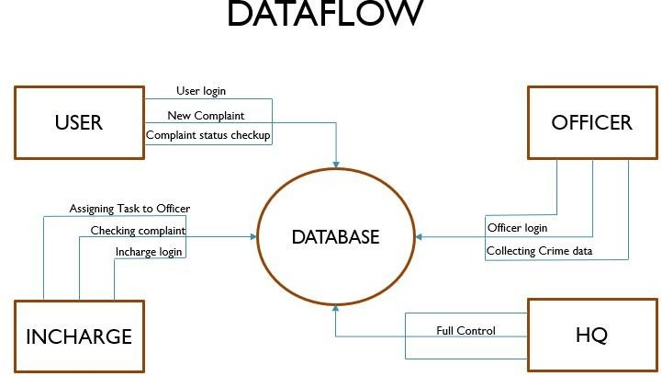

Fig. 1: Dataflow Diagram

#### PROJECT MODULES DESCRIPTION

* + 1. **Home Page**

This is the very first page that opens up on the localhost server from any web browser when we run this web application from the IDE. Here, the user gets to see four elements namely, Username, Password, Sign-in, and Sign-up.

User who is a complainer, can only access the two elements mentioned in the Home Page namely, Sign Up and User Login.

User who is an admin, can access all the elements mentioned in the Home Page namely, Sign Up, User Login, Official Login, Police Officer Login, Station Incharge Login, Head Quarter Login and Logout.

#### 3.2.2 User Login Page

Now, if the user is new to the web service, then he/she shall have to first register himself/herself by entering the required details and saving his/her account details to the connected database (which happens automatically at the back-end on just clicking the Sign-Up button). After this the user is redirected to the login page where he/she has to enter their username and password and sign-in to access their account.

If the user has an existing account, then he/she just simply need to enter their username and password and sign-in to access their account.

User after successfully Login, can access all the elements mentioned in the User Page namely, Log new complaint, Track Complaint Status and Logout.

#### Official Login Page

In this page there are three sections named as Police Officer Login, Station Incharge Login and Head Quarter Login.

User who is an admin, can access all the elements mentioned in the Official Login Page namely, Police Officer Login, Station Incharge Login and Head Quarter Login. Here, the admin has few additional features which he/she can use. Say, if the admin wants not only view the complaints but also to add and delete data, then the admin can use such additional features.

#### Police Officer Login Page

After clicking on this the officer will redirected to the officer login page where he/she has to enter their username and password and sign-in to access their account.

If the officer has an existing account, then he/she just simply need to enter their username and password and sign-in to access their account.

After successfully Login, can access all the elements mentioned in the Police officer Home Page namely, Complaint Details, Check Pending Complaint, can Update Complaint Progress, Show, Completed Complaint and Logout.

#### Station Incharge Login Page

After clicking on this the officer will redirected to the Incharge login page where he/she has to enter their username and password and sign-in to access their account.

If the officer has an existing account, then he/she just simply need to enter their username and password and sign-in to access their account.

After successfully Login, can access all the elements mentioned in the Station Incharge Home Page namely, View All Complaints, can assign cases to the police officers, Check Pending Complaint, Check Investigation status, Add new officer and Logout.

#### Head Quarter Login Page

After clicking on this the officer will redirected to the Head Quarter login page where he/she has to enter their username and password and sign-in to access their account.

If the officer has an existing account, then he/she just simply need to enter their username and password and sign-in to access their account.

After successfully Login, can access all the elements mentioned in the Head Quarter Home Page namely, View All Complaints, add new police station, add new Incharge, Search Complaint using Location, Delete a police station and Logout.

**Chapter 4**

**RESULT ANALYSIS AND VALIDATION**

**4.1 DATABASE ENTRIES:**

As the user runs the web application on a web browser, he/she is provided with a wide range of features to access. If the user is new, does sign up and logs into his/her account, all his/her entered credentials gets stored and updated into a database maintained in the back-end.

Similarly, this database stores and updates entries when accessing each feature provided to the user in the web service.

Below are some database entries which got updated after running each feature available in the web application:

* **Database and all the tables inside the database**

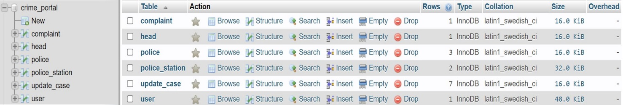

* **Complaint table: All the registered complaints will store here**

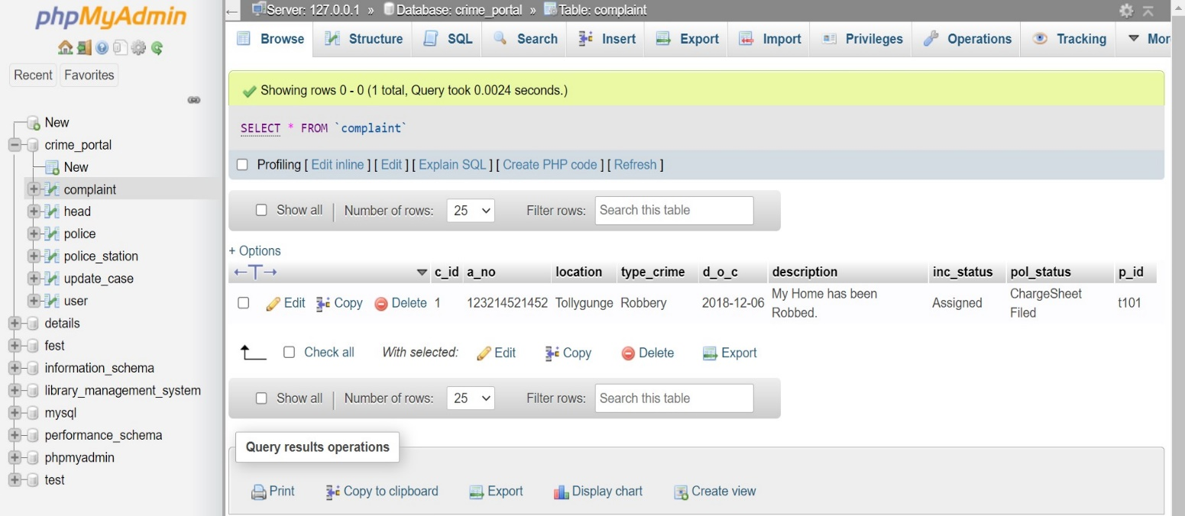

* **Head Table: All the Head Quarter Login Details will store here**

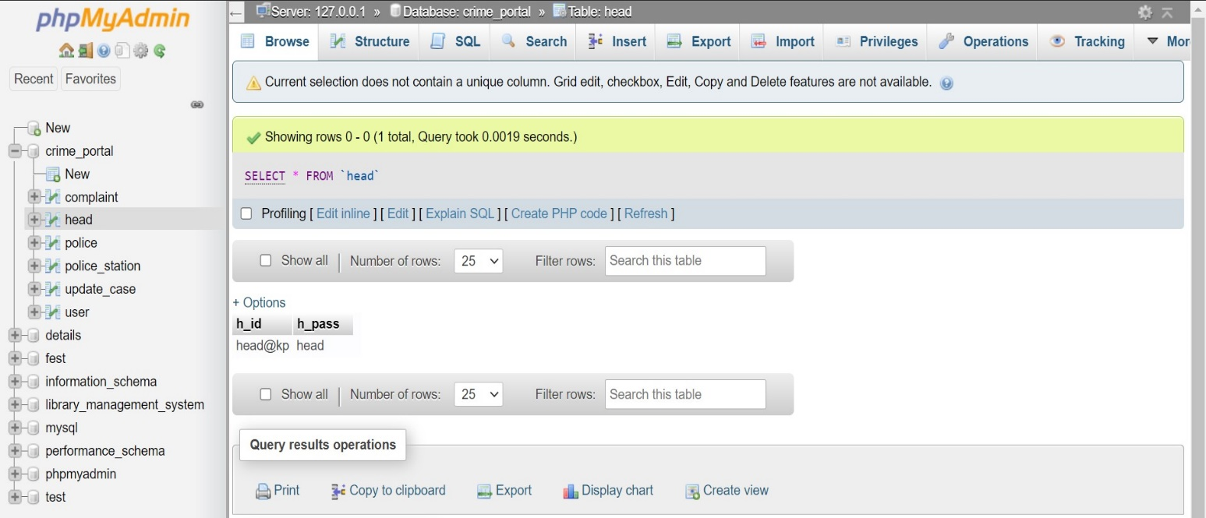

* **Police Table: All the police officer’s details will store here**

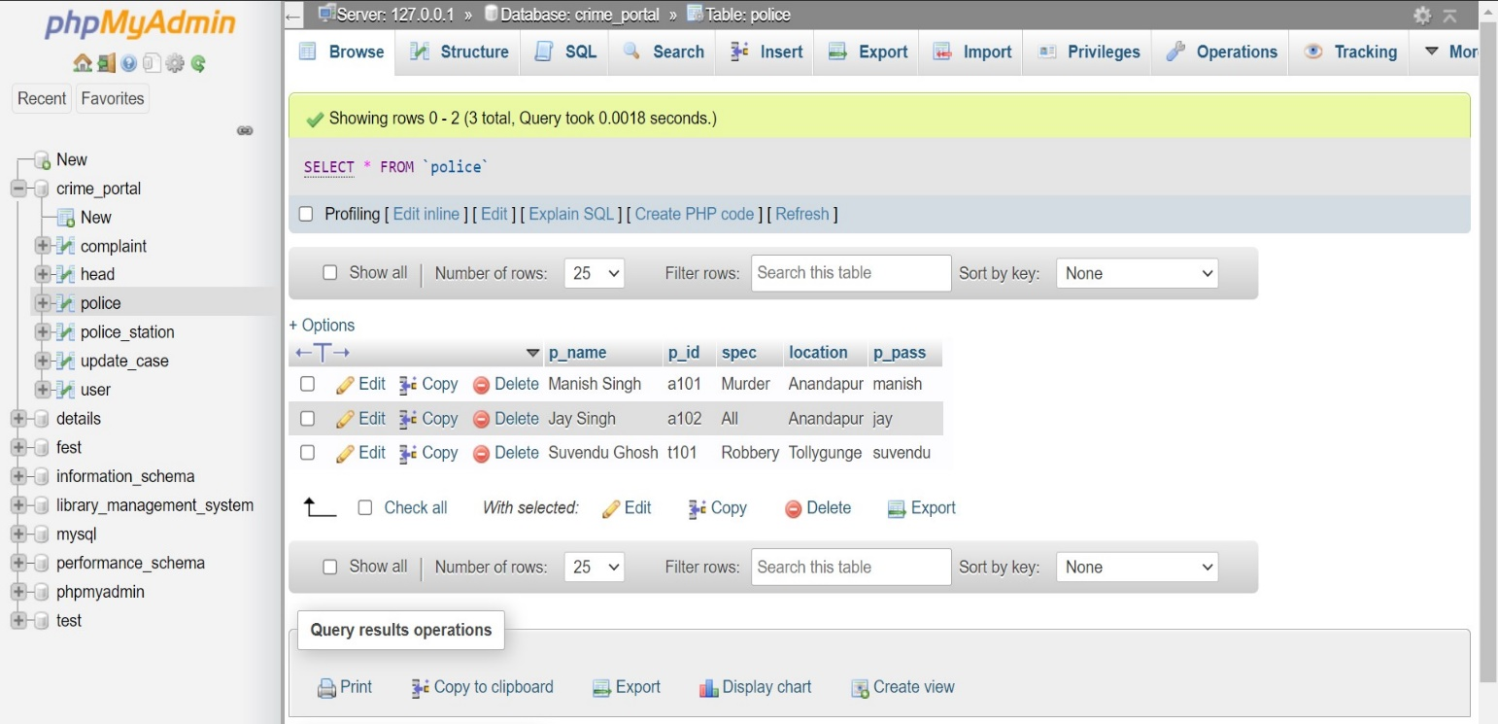

* **Police_Station Table: All the Station Incharge Login Details will store here.**

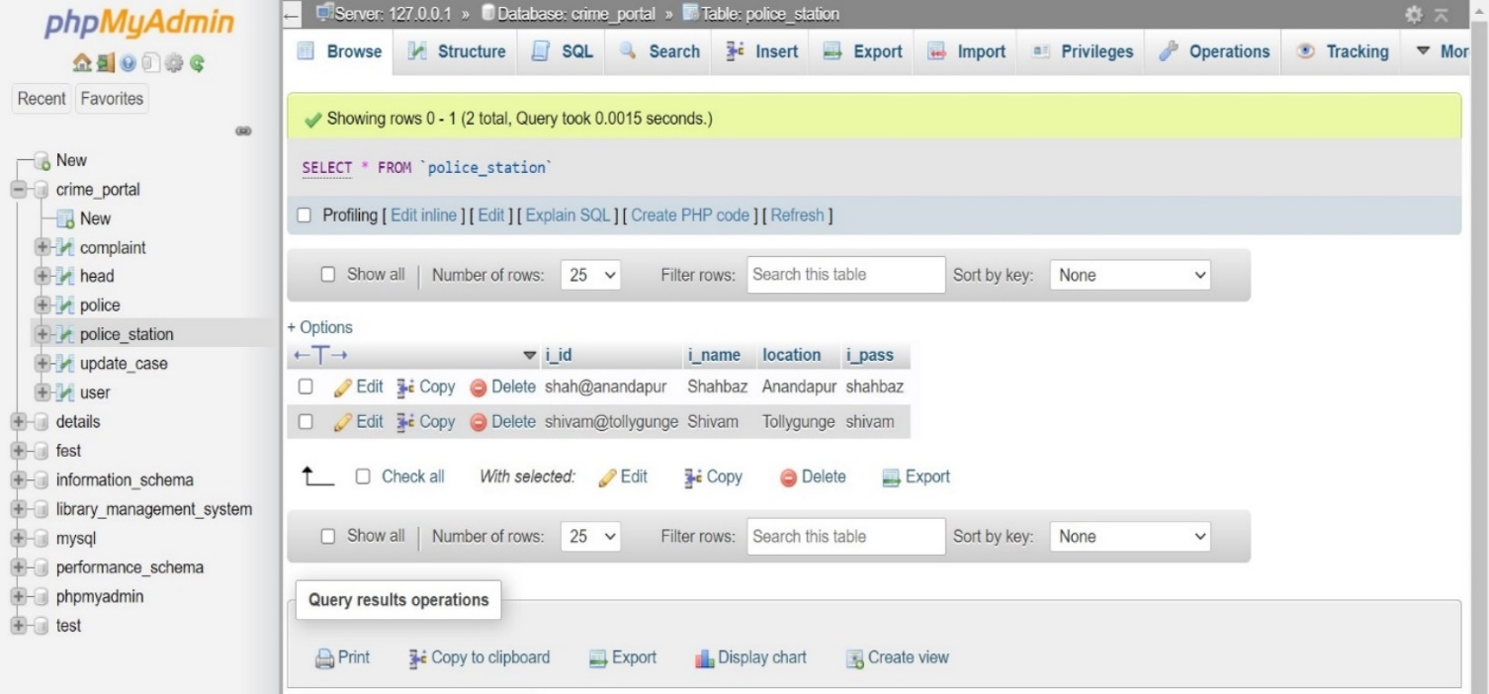

* **Update_Case Table: All the case progress details will store here.**

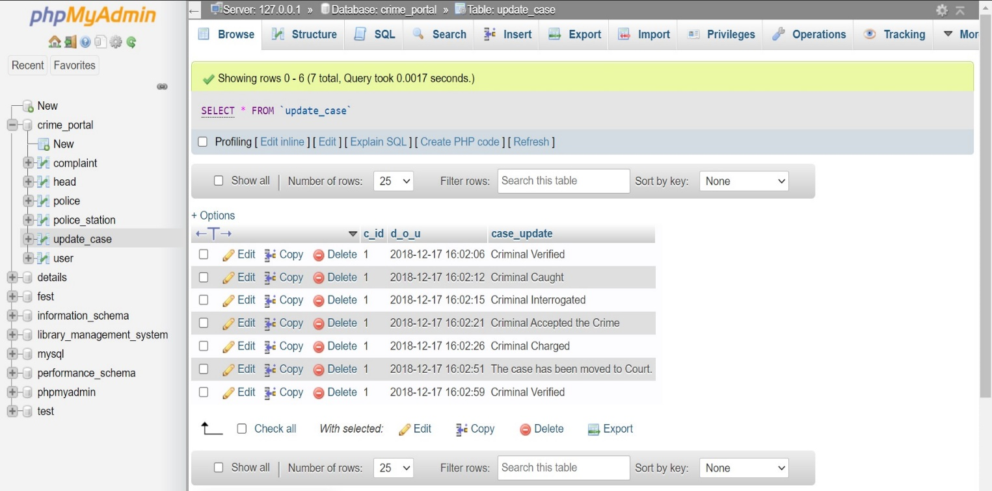

* **User Table: All the registered user details will show here**

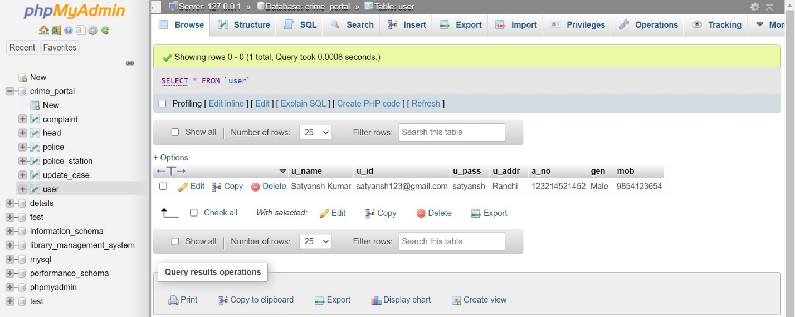

**Chapter 5**

**Outcome and Work Ethics**

**5.1 RESULT**

**5.1.1 Home Page:**

This is the very first page that opens up on the localhost server from any web browser when we run this web application from the IDE. Here, the user gets to see three elements namely, Sign Up, User Login, Official Login.

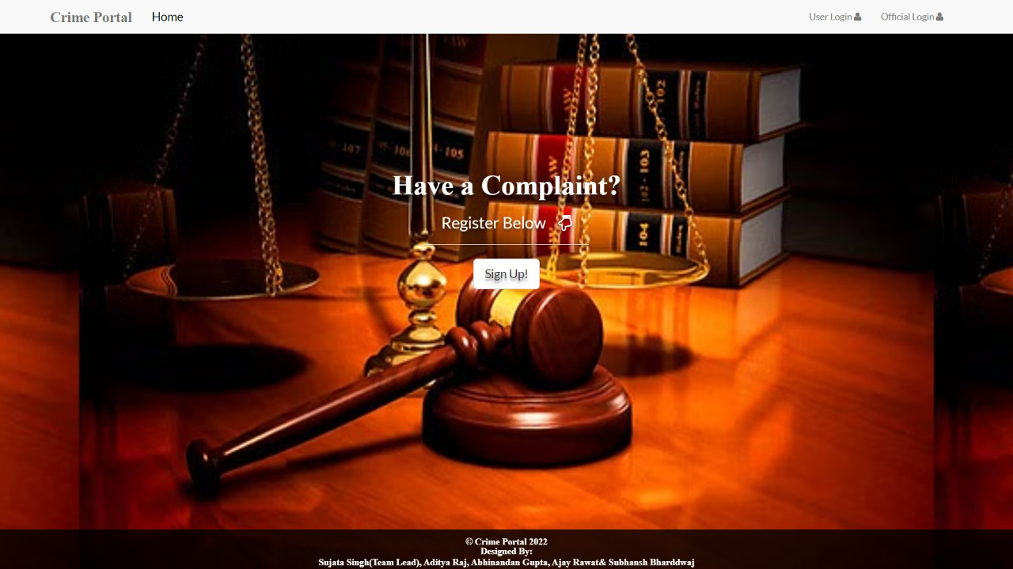

Now, if the user is new to the web service, then he/she shall have to first register himself/herself by entering the required details and saving his/her account details to the connected database (which happens automatically at the back-end on just clicking the Sign-Up button). After this the user is redirected to the login page where he/she has to enter their username and password and sign-in to access their account.

**5.1.2 User Registration page:**

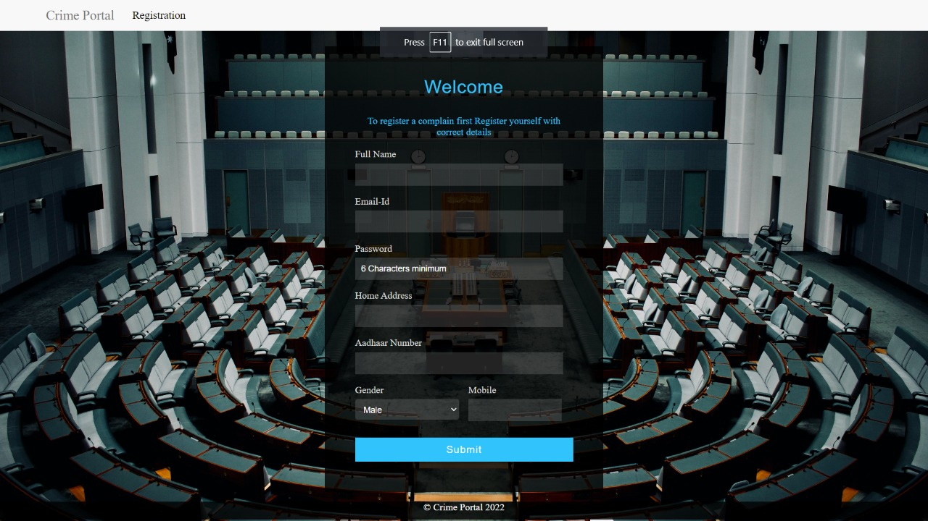

If the user has an existing account, then he/she just simply need to enter their username and password and sign-in to access their account.

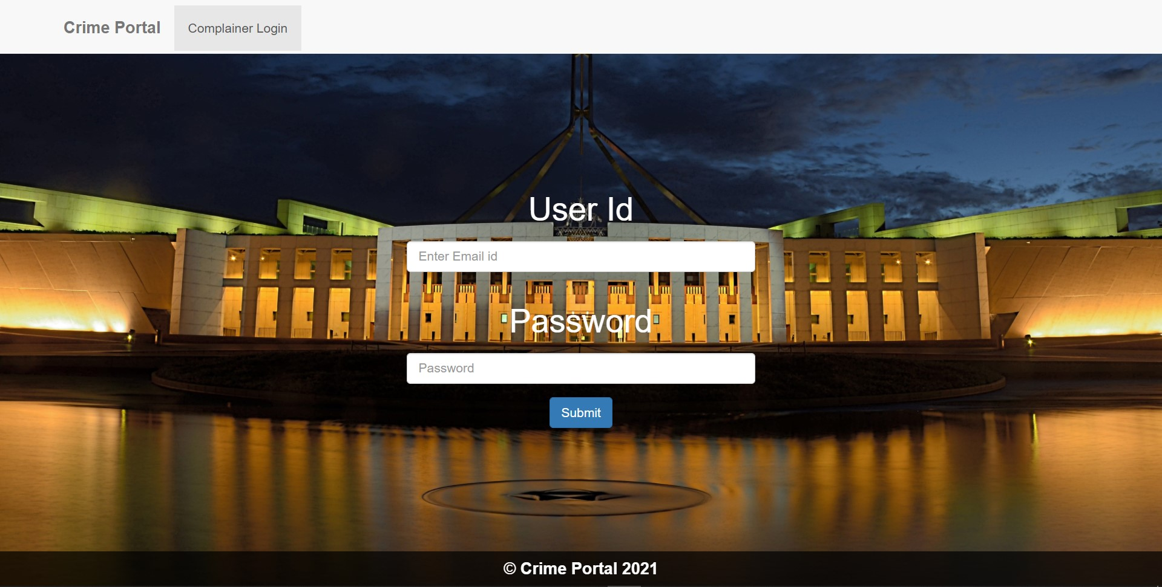**5.1.3 User Home Page**

This is the second page that opens up on the web browser when a user signs in to his/her account. Here, the user can be either a user or an admin.

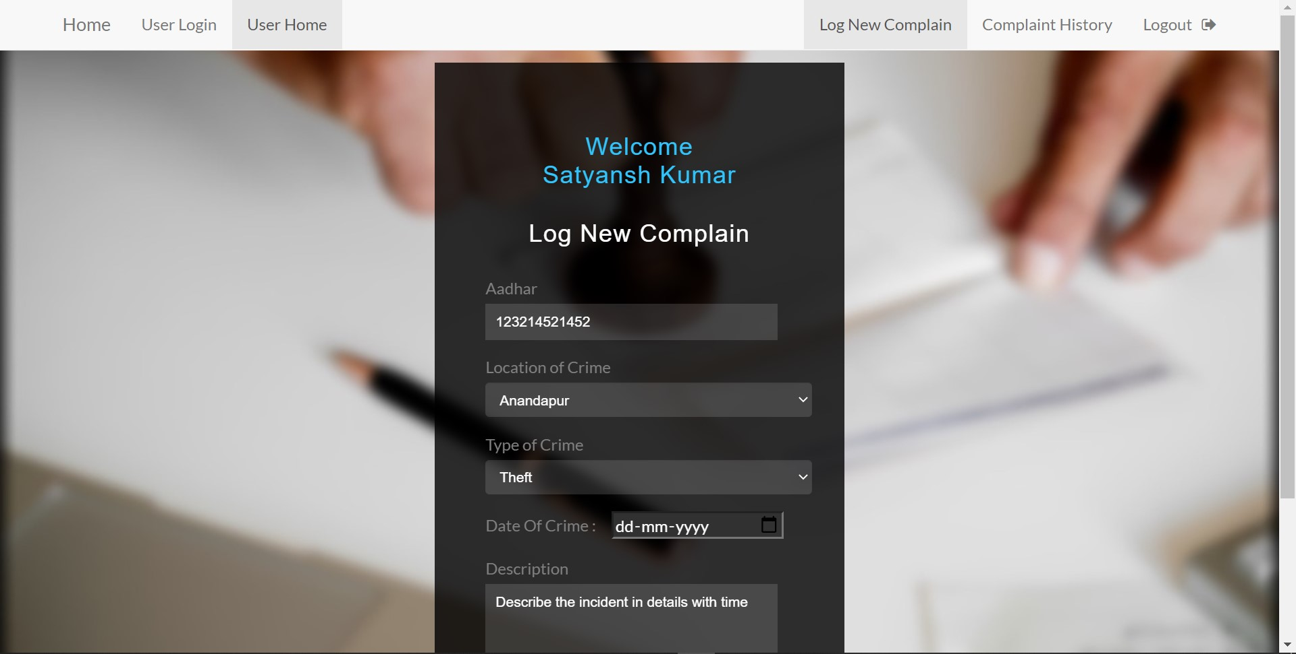

User who is a complainer, can only access the three elements mentioned in the Home Page namely, Log new complain, Complaint History, Log out.

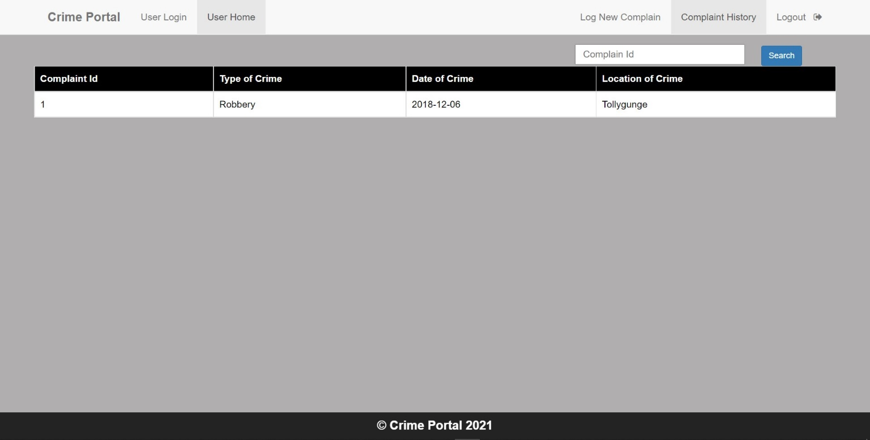

**5.1.4 Official Login Page**

This is the third page that opens up on the web browser when an officer signs in to his/her account.

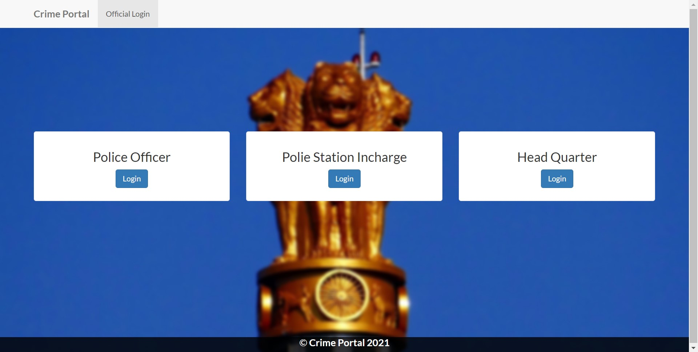

**5.1.5 Police Officer Login page**

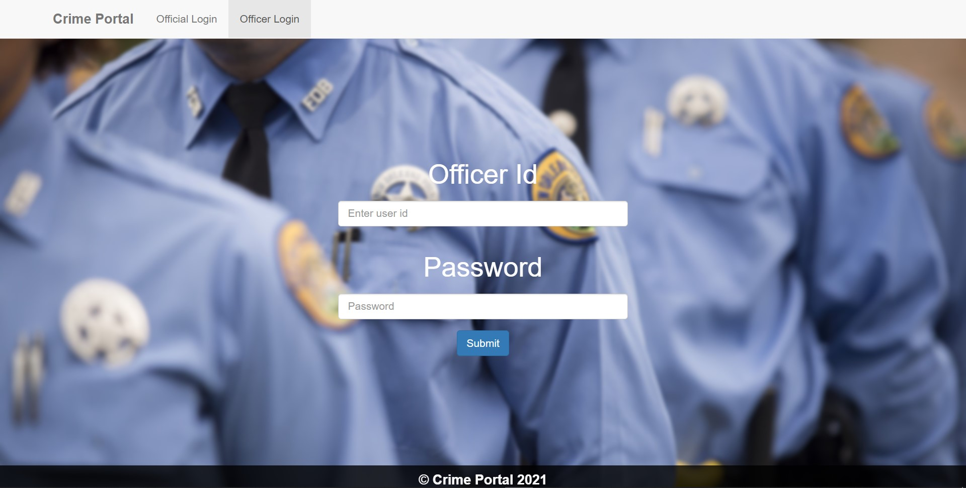

**5.1.6 Police Officer Home Page**

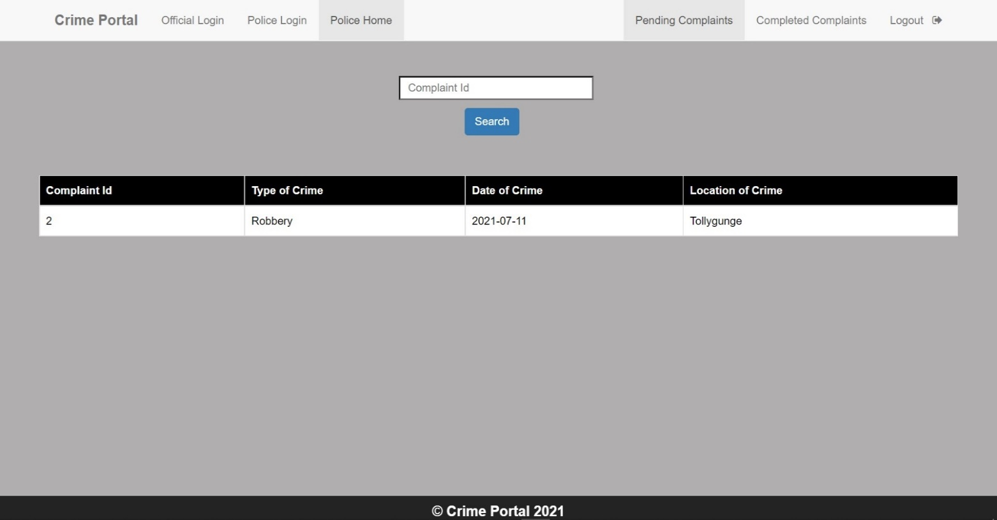

**5.1.7 Station In-charge Login Page**

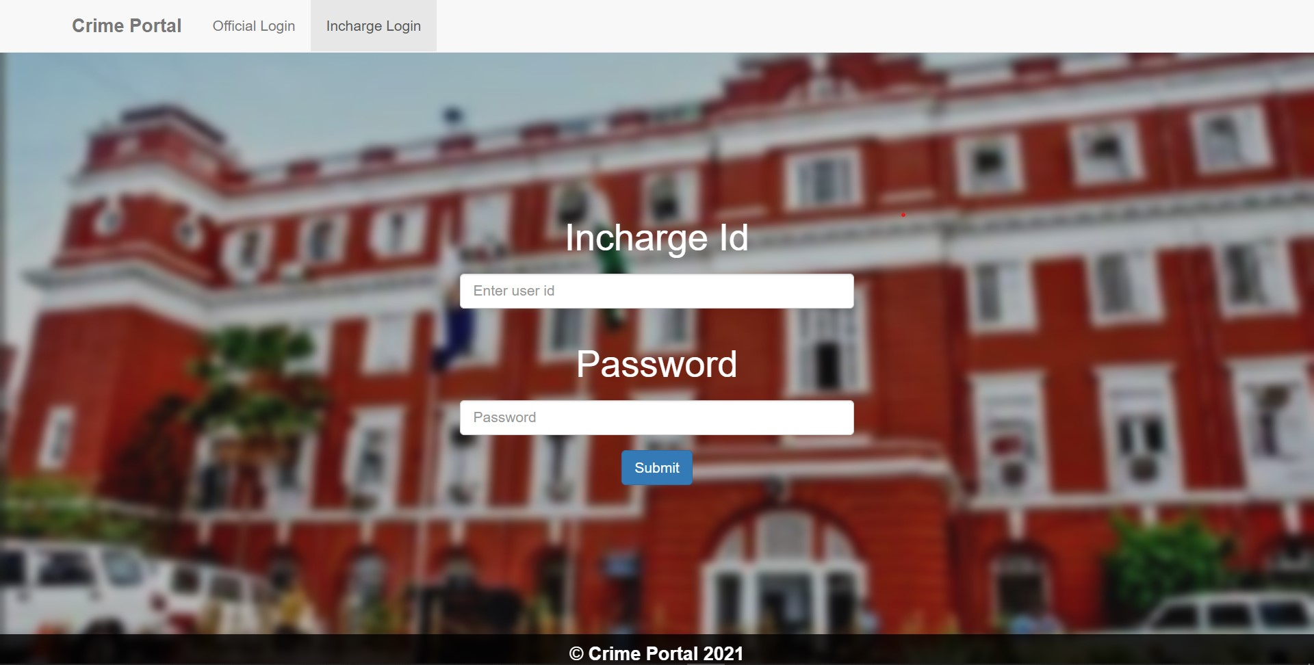

**5.1.8 Station In-charge Home Page**

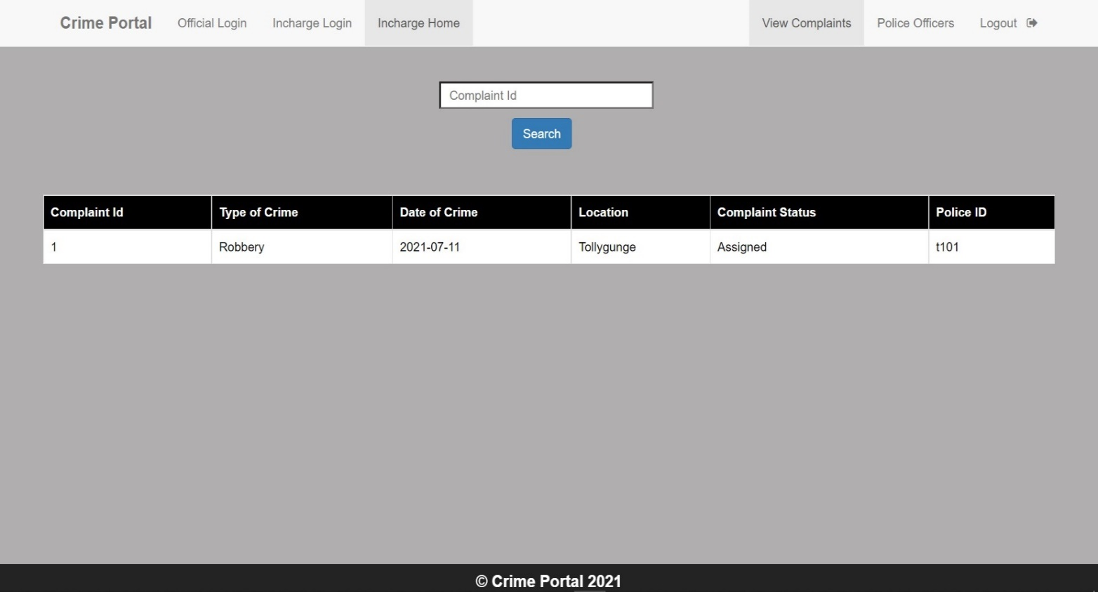

**5.1.9 Head Quarter Login Page**

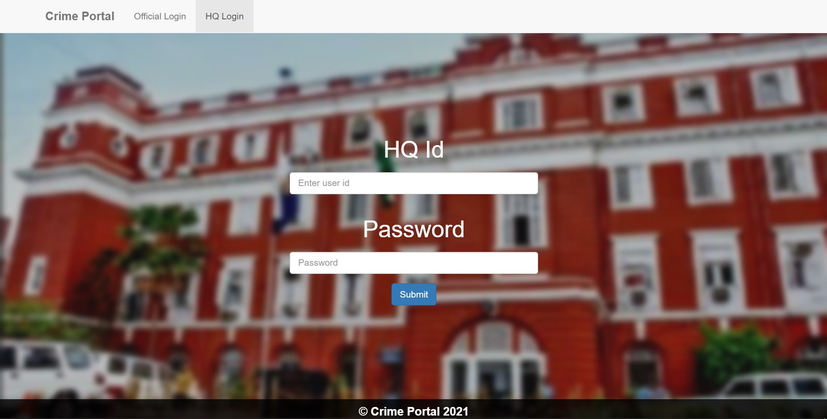

**5.1.10 Head Quarter Home Page**

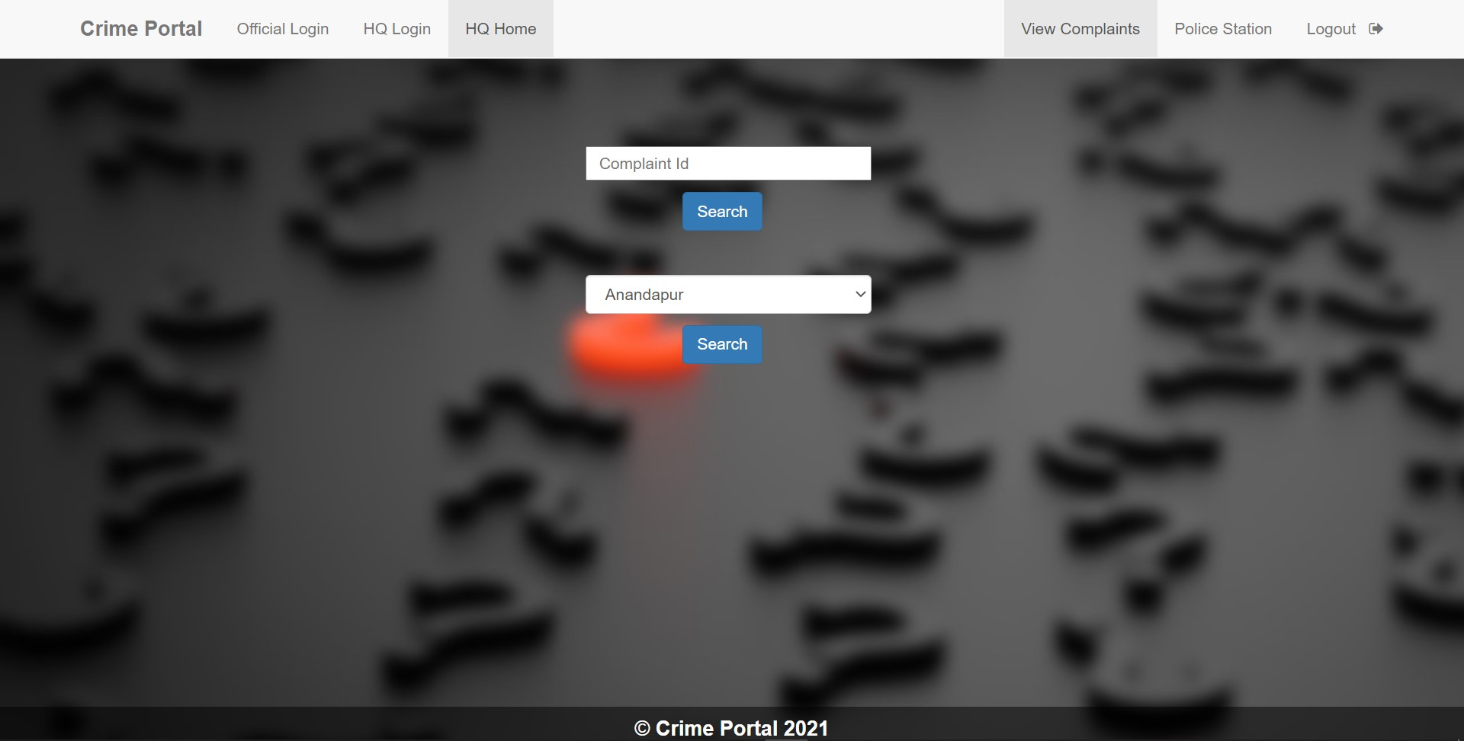

**5.1.11 New Police Station add Page**

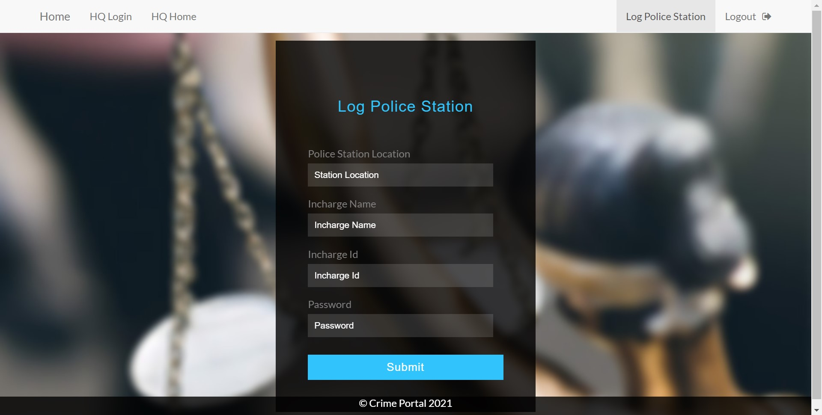

**5.2 APPLICATIONS**

• Can register a complain without visiting police station

• Customizable data and can see progress.

• Suitable for any type of crime

• Simple design

**5.3 CONCLUSION**

• With the help of this web service, the user will be able register his/her complain without visiting police station using this service and will be able to track the complaint status.

• Also, due to this system police department can now manage the rush time and investigate their case more efficiently. They will have option to check their pending complaints at any time.

• We checked all the modules in different web browsers and we got exactly the outcome from the web service we expected. We ran various existing and new user accounts on our web application, and all the processes went efficiently without a single error.

• We even checked the database connectivity and performance from the back-end using Xampp Server and PhpMyAdmin. We found that all the changes being made during runtime by the user using the various module features of the web application in a specific web browser is getting stored and updated in the MySQL database side by side.

**5.4 FUTURE SCOPE**

• We can give more advance software for online Crime Management systems

and add more facilities.

• We can add printer in the future.

• Integrate multiple load balancers to distribute the load of system.

• Create a backup mechanism for backing up data and informations.

• We will host the platform on online servers, to make it accessible

worldwide.

## 5.5 REFRENCES

* W3schools: <https://www.w3schools.com/html/>
* Tutorialspoint: <https://www.tutorialspoint.com/sql/sql-create-database.htm>
* Download Vs Code: <https://code.visualstudio.com/download>
* Xampp Server: <https://www.apachefriends.org/download.html>
* MySQL Workbench: <https://www.mysql.com/products/workbench/>